**Virtual Art Work Database**

Create DATABASE Gallery ;

use Gallery;

-- Create the Artists table

CREATE TABLE Artists (

ArtistID INT PRIMARY KEY,

Name VARCHAR(255) NOT NULL,

Biography TEXT,

Nationality VARCHAR(100));

-- Create the Categories table

CREATE TABLE Categories (

CategoryID INT PRIMARY KEY,

Name VARCHAR(100) NOT NULL);

-- Create the Artworks table

CREATE TABLE Artworks (

ArtworkID INT PRIMARY KEY,

Title VARCHAR(255) NOT NULL,

ArtistID INT,

CategoryID INT,

Year INT,

Description TEXT,

ImageURL VARCHAR(255),

FOREIGN KEY (ArtistID) REFERENCES Artists (ArtistID),

FOREIGN KEY (CategoryID) REFERENCES Categories (CategoryID));

-- Create the Exhibitions table

CREATE TABLE Exhibitions (

ExhibitionID INT PRIMARY KEY,

Title VARCHAR(255) NOT NULL,

StartDate DATE,

EndDate DATE,

Description TEXT);

-- Create a table to associate artworks with exhibitions

CREATE TABLE ExhibitionArtworks (

ExhibitionID INT,

ArtworkID INT,

PRIMARY KEY (ExhibitionID, ArtworkID),

FOREIGN KEY (ExhibitionID) REFERENCES Exhibitions (ExhibitionID),

FOREIGN KEY (ArtworkID) REFERENCES Artworks (ArtworkID));

-- Insert sample data into the Artists table

INSERT INTO Artists (ArtistID, Name, Biography, Nationality) VALUES

(1, 'Pablo Picasso', 'Renowned Spanish painter and sculptor.', 'Spanish'),

(2, 'Vincent van Gogh', 'Dutch post-impressionist painter.', 'Dutch'),

(3, 'Leonardo da Vinci', 'Italian polymath of the Renaissance.', 'Italian');

-- Insert sample data into the Categories table

INSERT INTO Categories (CategoryID, Name) VALUES

(1, 'Painting'),

(2, 'Sculpture'),

(3, 'Photography');

-- Insert sample data into the Artworks table

INSERT INTO Artworks (ArtworkID, Title, ArtistID, CategoryID, Year, Description, ImageURL) VALUES

(1, 'Starry Night', 2, 1, 1889, 'A famous painting by Vincent van Gogh.', 'starry_night.jpg'),

(2, 'Mona Lisa', 3, 1, 1503, 'The iconic portrait by Leonardo da Vinci.', 'mona_lisa.jpg'),

(3, 'Guernica', 1, 1, 1937, 'Pablo Picasso''s powerful anti-war mural.', 'guernica.jpg');

-- Insert sample data into the Exhibitions table

INSERT INTO Exhibitions (ExhibitionID, Title, StartDate, EndDate, Description) VALUES

(1, 'Modern Art Masterpieces', '2023-01-01', '2023-03-01', 'A collection of modern art masterpieces.'),

(2, 'Renaissance Art', '2023-04-01', '2023-06-01', 'A showcase of Renaissance art treasures.');

-- Insert artworks into exhibitions

INSERT INTO ExhibitionArtworks (ExhibitionID, ArtworkID) VALUES

(1, 1),

(1, 2),

(1, 3),

(2, 2);

***--Queries***

--1.Retrieve the names of all artists along with the number of artworks they have in the gallery, and list them in descending order of the number of artworks.

SELECT Artists.Name, COUNT(Artworks.ArtworkID) AS No_of_Artworks

FROM Artists

LEFT JOIN Artworks ON Artists.ArtistID = Artworks.ArtistID

GROUP BY Artists.ArtistID, Artists.Name

ORDER BY No_of_Artworks DESC;

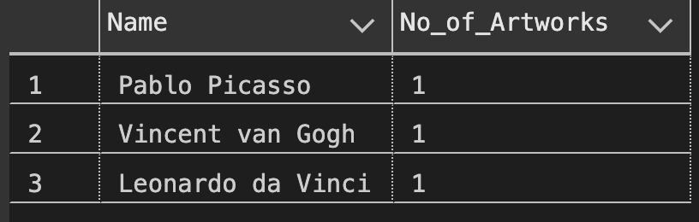

--2. List the titles of artworks created by artists from 'Spanish' and 'Dutch' nationalities, and order them by the year in ascending order.

SELECT Artworks.Title, Artworks.Year

FROM Artworks

JOIN Artists ON Artworks.ArtistID = Artists.ArtistID

WHERE Artists.Nationality IN ('Spanish', 'Dutch')

ORDER BY Artworks.Year ASC;

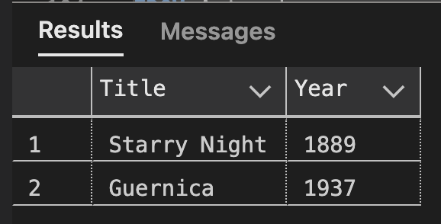

--3. Find the names of all artists who have artworks in the 'Painting' category, and the number of artworks they have in this category.

SELECT Artists.Name, COUNT(Artworks.ArtworkID) AS No_of_Artworks

FROM Artists

JOIN Artworks ON Artists.ArtistID = Artworks.ArtistID

WHERE Artworks.CategoryID = 1 -- Assuming 'Painting' has CategoryID 1

GROUP BY Artists.ArtistID, Artists.Name;

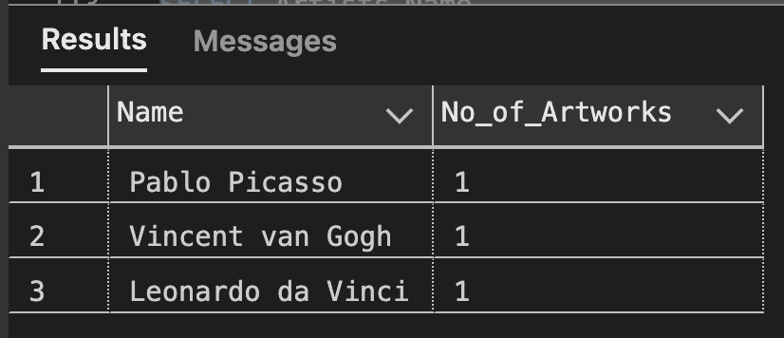

--4. List the names of artworks from the 'Modern Art Masterpieces' exhibition, along with their artists and categories.

SELECT Artworks.Title, Artists.Name AS Artist, Categories.Name AS Category

FROM Artworks

JOIN ExhibitionArtworks ON Artworks.ArtworkID = ExhibitionArtworks.ArtworkID

JOIN Exhibitions ON ExhibitionArtworks.ExhibitionID = Exhibitions.ExhibitionID

JOIN Artists ON Artworks.ArtistID = Artists.ArtistID

JOIN Categories ON Artworks.CategoryID = Categories.CategoryID

WHERE Exhibitions.Title = 'Modern Art Masterpieces';

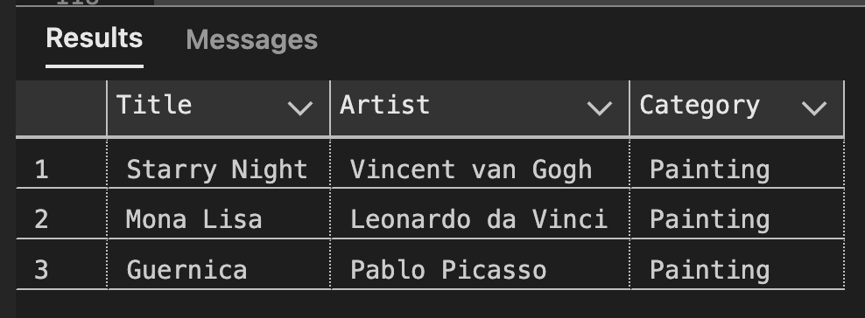

--5. Find the artists who have more than two artworks in the gallery.

SELECT Artists.Name

FROM Artists

JOIN Artworks ON Artists.ArtistID = Artworks.ArtistID

GROUP BY Artists.ArtistID, Artists.Name

HAVING COUNT(Artworks.ArtworkID) > 2;



--6. Find the titles of artworks that were exhibited in both 'Modern Art Masterpieces' and 'Renaissance Art' exhibitions

SELECT Artworks.Title

FROM Artworks

JOIN ExhibitionArtworks ON Artworks.ArtworkID = ExhibitionArtworks.ArtworkID

JOIN Exhibitions ON ExhibitionArtworks.ExhibitionID = Exhibitions.ExhibitionID

WHERE Exhibitions.Title IN ('Modern Art Masterpieces', 'Renaissance Art')

GROUP BY Artworks.Title

HAVING COUNT(DISTINCT Exhibitions.ExhibitionID) = 2;



--7. Find the total number of artworks in each category

SELECT Categories.Name, COUNT(Artworks.ArtworkID) AS TotalArtworks

FROM Categories

LEFT JOIN Artworks ON Categories.CategoryID = Artworks.CategoryID

GROUP BY Categories.CategoryID, Categories.Name;

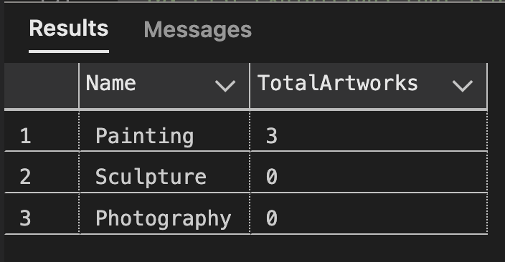

--8. List artists who have more than 3 artworks in the gallery.

SELECT Artists.Name

FROM Artists

JOIN Artworks ON Artists.ArtistID = Artworks.ArtistID

GROUP BY Artists.ArtistID, Artists.Name

HAVING COUNT(Artworks.ArtworkID) > 3;



--9. Find the artworks created by artists from a specific nationality (e.g., Spanish).

SELECT Artworks.Title, Artists.Name

FROM Artworks

JOIN Artists ON Artworks.ArtistID = Artists.ArtistID

WHERE Artists.Nationality = 'Spanish';



--10. List exhibitions that feature artwork by both Vincent van Gogh and Leonardo da Vinci.

SELECT Exhibitions.Title

FROM Exhibitions

JOIN ExhibitionArtworks ON Exhibitions.ExhibitionID = ExhibitionArtworks.ExhibitionID

JOIN Artworks ON ExhibitionArtworks.ArtworkID = Artworks.ArtworkID

JOIN Artists ON Artworks.ArtistID = Artists.ArtistID

WHERE Artists.Name IN ('Vincent van Gogh', 'Leonardo da Vinci')

GROUP BY Exhibitions.ExhibitionID, Exhibitions.Title

HAVING COUNT(DISTINCT Artists.ArtistID) = 2;



--11. Find all the artworks that have not been included in any exhibition.

SELECT Artworks.Title

FROM Artworks

LEFT JOIN ExhibitionArtworks ON Artworks.ArtworkID = ExhibitionArtworks.ArtworkID

WHERE ExhibitionArtworks.ArtworkID IS NULL;



--12. List artists who have created artworks in all available categories.

SELECT Artists.Name

FROM Artists

CROSS JOIN Categories

WHERE NOT EXISTS (

SELECT 1

FROM Categories

LEFT JOIN Artworks ON Categories.CategoryID = Artworks.CategoryID

LEFT JOIN Artists ON Artworks.ArtistID = Artists.ArtistID

WHERE Artists.ArtistID IS NULL

);



--13. List the total number of artworks in each category.

SELECT Categories.Name, COUNT(Artworks.ArtworkID) AS TotalArtworks

FROM Categories

LEFT JOIN Artworks ON Categories.CategoryID = Artworks.CategoryID

GROUP BY Categories.CategoryID, Categories.Name;

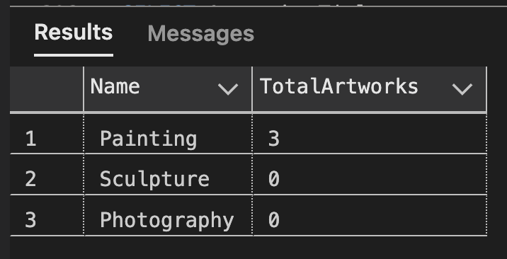

--14. Find the artists who have more than 2 artworks in the gallery.

SELECT Artists.Name

FROM Artists

JOIN Artworks ON Artists.ArtistID = Artworks.ArtistID

GROUP BY Artists.ArtistID, Artists.Name

HAVING COUNT(Artworks.ArtworkID) > 2;



--15. List the categories with the average year of artworks they contain, only for categories with more than 1 artwork.

SELECT Categories.Name, AVG(Artworks.Year) AS AvgYear

FROM Categories

JOIN Artworks ON Categories.CategoryID = Artworks.CategoryID

GROUP BY Categories.CategoryID, Categories.Name

HAVING COUNT(Artworks.ArtworkID) > 1;



--16. Find the artworks that were exhibited in the 'Modern Art Masterpieces' exhibition.

SELECT Artworks.Title

FROM Artworks

JOIN ExhibitionArtworks ON Artworks.ArtworkID = ExhibitionArtworks.ArtworkID

JOIN Exhibitions ON ExhibitionArtworks.ExhibitionID = Exhibitions.ExhibitionID

WHERE Exhibitions.Title = 'Modern Art Masterpieces';

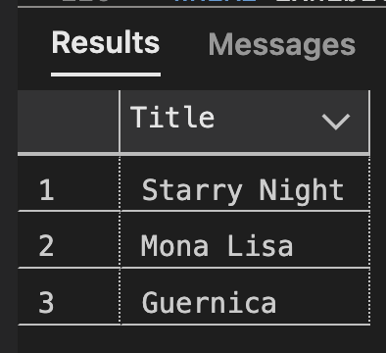

--17. Find the categories where the average year of artworks is greater than the average year of all artworks.

SELECT Categories.Name, AVG(Artworks.Year) AS AvgCategoryYear, AVG(AvgAllArtworksYear) AS AvgAllArtworksYear

FROM Categories

JOIN Artworks ON Categories.CategoryID = Artworks.CategoryID

CROSS JOIN (SELECT AVG(Year) AS AvgAllArtworksYear FROM Artworks) AS AllArtworksAvg

GROUP BY Categories.CategoryID, Categories.Name

HAVING AVG(Artworks.Year) > AVG(AvgAllArtworksYear);



--18. List the artworks that were not exhibited in any exhibition.

SELECT Artworks.Title

FROM Artworks

LEFT JOIN ExhibitionArtworks ON Artworks.ArtworkID = ExhibitionArtworks.ArtworkID

WHERE ExhibitionArtworks.ArtworkID IS NULL;



--19. Show artists who have artworks in the same category as "Mona Lisa."

SELECT DISTINCT Artists.Name

FROM Artists

JOIN Artworks AS MonaLisaArtwork ON Artists.ArtistID = MonaLisaArtwork.ArtistID

JOIN Categories ON MonaLisaArtwork.CategoryID = Categories.CategoryID

JOIN Artworks ON Categories.CategoryID = Artworks.CategoryID

WHERE Artworks.Title = 'Mona Lisa';

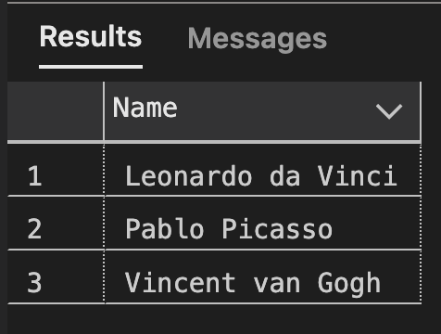

--20. List the names of artists and the number of artworks they have in the gallery.

SELECT Artists.Name, COUNT(Artworks.ArtworkID) AS No_of_Artworks

FROM Artists

LEFT JOIN Artworks ON Artists.ArtistID = Artworks.ArtistID

GROUP BY Artists.ArtistID, Artists.Name;

